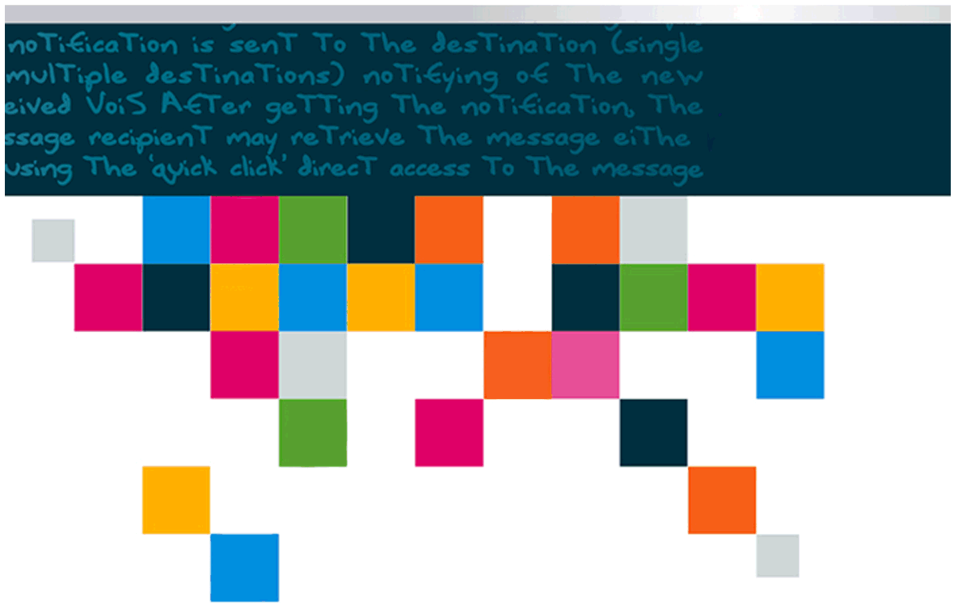

**Response to Vietnam Telecom Service Company (VNP)**

**Upgrade and Expansion of PPS-IN**

System Dimensioning/Sizing

Table of Contents

1. C1- RT Hardware Platform 4

1.1 Performance Improvements 4

1.1.1 SDP 4

1.1.2 Centralize voucher - SDP 4

1.1.3 SGU 5

1.1.4 Voice SLU 5

1.1.5 Payment Server 5

1.1.6 SAPI/CCWS 5

1.2 New Elements for Vinaphone 6

1.2.1 OSA SLU 6

1.2.2 CAP3 GPRS SLU 6

1.2.3 CAP3 SMS SLU 6

1.2.4 IVR CMS 7

1.2.5 Diameter DGU 7

1.2.6 Diameter DLU 7

2. Configuration parameters 8

3. Dimensioning Calculations 10

3.1 SDP Sizing 10

3.1.1 Standard traffic for 2.0M expansion Calculation 10

3.1.2 More powerful remaining capacity of SDP’s to support new Interface and Feature (Postpaid, OSA/Diameter,...) 10

3.1.3 Functionalities are supported postpaid subscriber 11

3.2 CAP SGU Sizing 11

3.2.1 Requirement for 2.0M expansion 11

3.2.2 Capacity of SGU’s provided for 2.0M expansion 11

3.3 Voice SLU Sizing 12

3.3.1 Requirement 2.0M expansion 12

3.3.2 Capacity of SLU’s Voice provided for 2.0M expansion 12

3.4 SMS CAP3-SLU Sizing 12

3.4.1 Requirement and provided for 2.0M expansion 12

3.5 SAPI/CCWS SLU Sizing 12

3.6 Notification SLU Sizing 12

3.7 Mediation for Vinaphone special interfaces 13

Mediation for offline Charging, HLR Synchronization and Promotion Adjustments, Re-rating option 13

3.8 Other Equipments 13

3.9 Diameter 14

3.9.1 Diameter DGU sizing for 2.0M expansion 14

3.9.2 Diameter DLU sizing 2.0M expansion 14

3.10 IVR Sizing 14

4. Diameter expansion for 53.5M existing Subscriber 15

4.1 SDP sizing 15

4.2 Diameter DGU full fill to support 53.5M existing Subscriber 15

4.3 Diameter DSLU full fill to support 53.5M existing Subscriber **Error! Bookmark not defined.**

# 1. C1- RT Hardware Platform

The proposal for the expansion 750k (~6M TPH) concurrent session Diameter, 200M Voucher and 2.0M Postpaid subscribers.

The functionalities are supported within this version and are included in the proposal. These are, SMS Charging on CAMEL3, Data Charging using Diameter/OSA, VPN, Group Accounts, Multiple Identities and Calling Circles.

There are significant improvements as well on performance as detailed in the proceeding section.

The functionalities are supported postpaid subscriber within this version. The following are main activities

* System configuration for RT Postpaid subscriber such as network prefix, range map, and others
* Offers configuration for RT postpaid subscriber
* Activity/Calendar/Tariff/Promotion/… configuration for RT postpaid
* URP/ORP configuration for file based transaction of postpaid subscriber
* Re-Rating criteria
* Process for Rated CDR file transfer

## Performance Improvements

The tables below show the benchmark performance figures of each element

### SDP

|  |  |
| --- | --- |
| SDP | |
| HE IBM (p570 w/ p5) | 6M BHCE |
| HE IBM (p570 w/ p5+) | 10M BHCE |
| HE IBM (p570 w/ p6) | 15M BHCE |
| HE IBM (p570 w/ p7) | 15M BHCE |

### Centralize voucher - SDP

|  |  |
| --- | --- |
| SDP | |
| HE IBM (p570 w/ p6) | 200-300M vouchers |

### SGU

SGU HSL capacity assumes 4 X 2Mb/s links (full E1 bandwidth each) based on 0.4 erlang. Lower erlang values or less actual links would reduce the capacity respectively.

|  |  |  |
| --- | --- | --- |
| SGU | | |
| CAP2 over HSL | DPM3 | 3.5M BHCA |
| CAP3-SMS over HSL | DPM3 | 1.8M BHSM |
| CAP2 over HSL | HS21/22 | 3.5M BHCA |
| CAP3-SMS over HSL | HS21/22 | 3.5M BHSM |

### Voice SLU

|  |  |  |
| --- | --- | --- |
| Voice SLU | | |
| Voice Calls | DPM3 | 350k BHCA |
| Voice Calls | HS21/22 | 500k BHCA |

### Payment Server

|  |  |  |
| --- | --- | --- |
| Payment Server | | |
| Payment server capacity BHSM (Apply Tariff Transaction) | DPM3 | 554K BHSM |

### SAPI/CCWS

New Single API – SAPI, The Unified Application Programming Interface (API) is a single framework that maintains full transactional integrity across the portfolio and is adaptive to deployment modes.

SAPI/CCWS capacity is dependent on the operations performed. SAPI/CCWS capacity is therefore averaged across the different projected CCWS usage profile based on what we know in VNP and our experience with other operators.

|  |  |  |
| --- | --- | --- |
| SAPI/CCWS | | |
| Average capacity | DPM3 | 35 / Sec |
| Average capacity | HS21/22 | 40 / Sec |

## New Elements for Vinaphone

Some of the new functionalities introduced imply the need for new hardware elements. Benchmark figures for these new elements are shown in the tables below:

### OSA SLU

Open Service Access or OSA is used for charging of data services. OSA may be used as an interface to VNP’s Data Application Servers.

|  |  |  |
| --- | --- | --- |
| OSA SLU | | |
| Reserve/Debit Amount | DPM2 or DPM3 | 365K /hour |

### CAP3 GPRS SLU

GPRS usage may be charged using a CAMEL 3 interface to the GPRS Node.

|  |  |  |
| --- | --- | --- |
| CAP3 GPRS SLU | | |
| GPRS Sessions | DPM2 or DPM3 | 295K /hour |

### CAP3 SMS SLU

SMS transations may be charged using a CAMEL 3 interface to the SMS Server.

|  |  |
| --- | --- |
| CAP3 SMS SLU | |
| DPM3 | 384K BHSM |
| HS21/22 | 550K BHSM |

### IVR CMS

|  |  |
| --- | --- |
| CMS | |
| CMS DPM3 | 60K BHCA |
| CCS DPM3 | 250K BHCA |
| CMS HS21/22 | 90K BHCA |
| CCS HS21/22 | 250K BHCA |

### Diameter DGU

|  |  |  |
| --- | --- | --- |
| Diameter DGU | | |
| Event/Transaction base traffic (with assumption of 3 CCR/CCA per transaction) | DPM3 | 3,000K **/**hour or 288K Concurrent session |
| Event/Transaction base traffic (with assumption of 3 CCR/CCA per transaction) | HS21/22 | 3,000K **/**hour or 320K Concurrent session |

### Diameter DLU

|  |  |  |
| --- | --- | --- |
| Diameter DGU | | |
| Event/Transaction base traffic (with assumption of 4 CCR/CCA per transaction) | DPM3 | 140K **/**hour or 18K Concurrent session |
| Event/Transaction base traffic (with assumption of 4 CCR/CCA per transaction) | HS21/22 | 140K **/**hour or 18K Concurrent session |

# Configuration parameters

The table below lists the traffic parameters for 2.0M expansion.

|  |  |
| --- | --- |
| **Traffic & Sizing assumptions (by Vinaphone)** | **Value** |
| Number of subscriber | 2,000,000 |
| BHCA per subscriber | 1.0 BHCA |
| Erlang per subscriber | 25mErl |
| BHSM | 0.3 |
| GoS | 0.01% |
| OC (MOC and MMC) | 55% |
| MTC | 45% |
| USSD refill | 0.02 |
| USSD enquiries | 0.08 |
| E-load refill | 05 refills/s |
| Erlang per C7 Link (64Kbps) | 0.2 Erl |
| Erlang per C7 HSL (2Mbps) | 0.4 Erl |

The table below lists the traffic parameters for new Interface / Feature / Function with Traffic & Sizing assumptions (by Comverse)for 2.0M expansion.

|  |  |
| --- | --- |
| **Feature & Function** | **Value** |
| GSM Data/Fax Bearer Capability | Via CAP2 signaling capability |
| External Recharge Interface Enhancements | Via mediation gateway with VSIP protocol support |
| Revenue Assurance   * ORP Enhancements | Via Comverse ORP (Outage Record Processing) and URP (Offline Usage Record processing) |
| Group Account   * Group Account Enhancements | 2.0M subscriber licenses |
| Multiple Identities | 2.0M subscriber licenses (via the shadow subscribers) |
| Calling Circles | 2.0M subscriber licenses |
| SMS real time charging | SMS real time charging over 2.0M Sub with 0.3 BHSM |
| Diameter real time charging | 80K concurrent sessions or 640K Transaction base traffic |

# Dimensioning Calculations

Note: The in-practice sizing calculation formulas are highly complicated due to the C1-RT system complexity. The figures illustrated as follows represent ‘rules of thumb’ to draw the rough calculation figures hence actual slight differences may occur.

## SDP Sizing

### Standard traffic for 2.0M expansion Calculation

**a.** Voice traffic for 2.0M expansion: 2,000K * (1.0 (Voice) + 0.1(USSD)) = 2,200K BHCE

**b.** Reservation for traffic based on 10%: 2,200K * 0.1 = 220K BHCE

**c.** CAP3-SMS which will support 2.0M subs at: 2,000K * 0.3 *1.123(CE) = 674K BHCE

**d.** USSD info request: 0.08 * 0.5(CE) * 2,000K = 80K BHCE

**e.** USSD recharge request: 0.02 * 6.88(CE) * 2,000K = 276K BHCE

**f.** Notification traffic (assume max 10%) for 2.0M subs at: 2,000K * 0.1 * 1(CE) = 200K BHCE

**g.** SAPI/CCWS traffic for 2.0M subs at: 2,000K * 0.2 * 6(CE) = 2,400K BHCE

Total Standard traffic for 2.0M expansion is ***6,050K BHCE***

Additional **ONE** High-End IBM P7 SDP will be needed. It has a capacity of **15,000K** BHCE

### More powerful remaining capacity of SDP’s to support new Interface and Feature (Postpaid, OSA/Diameter,...)

*Expectation traffic calculation for new Interface and Feature in case VNP wants to use:*

**a.** Calling Circle based traffic for new 2.0M: 2,000K *1.00*0.11 = 220K BHCE

**b.** Group Account based traffic for new 2.0M: 2,000K *1.00 *1 (CE) = 2,000K BHCE

**c.** Multiple Identity based traffic for new 2.0M: 2,000K *1.00 *1.57(CE)*0.12(usage) = 377.0K BHCE

**d.** Additional notification traffic (assume max 20%) for new 2.0M: 2,000K * 0.2 * 1(CE) = 400K BHCE

**d.** Additional Diameter traffic (assume max 60%) for new 2.0M: 2,000K * 0.6* 1.5(CE) = 1,800K BHCE

Total new Interface and Feature traffic for 2.0M expansion is ***4,797.00K BHCE***

Remaining capacity of SDP can handle traffic of new Interface and Feature.

### Functionalities are supported postpaid subscriber

Additional ONE High-End IBM P7 SDP will support:

* System configuration for RT Postpaid subscriber such as network prefix, range map, and others
* Offers configuration for RT postpaid subscriber
* Activity/Calendar/Tariff/Promotion/… configuration for RT postpaid
* URP/ORP configuration for file based transaction of postpaid subscriber
* Re-Rating criteria
* Data Base and Process for Rated CDR file transfer
* Data Base and Process for Data Mediation

## CAP SGU Sizing

The SGU (CAP2) with HSL link supports up-to 3,500K BHCA

The SGU (CAP2/CAP3) with HSL link for CAP3-SMS support 3.5M BHSM/BHCA

### Requirement for 2.0M expansion

Total BHCA for 2.0M expansion for voice = 2,000K * (1.0 BHCA (Voice) + 0.1 (USSD)) = ***2,200K BHCA***

Total BHSM for 2.0M expansion for SMS = 2,000K * (0.3 BHSM (SMS)) = ***600K BHSM***

### Capacity of SGU’s provided for 2.0M expansion

Additional 01 SGU Voice with HSL will be needed. It has a capacity of 3,500K BHCA

Additional 01 SGU SMS with HSL will be needed. It has a capacity of 3,500K BHCA

**Total SGU capacity for CAP2/CAP3 is = 3,500K +3,500K = 7,000K BHCA/BHSM**

## Voice SLU Sizing

The HS21/22 SLU supports up to 500K BHCA

### Requirement 2.0M expansion

Total BHCA capacity for new 2.0M expansion subs 2.000K*(1.0 (voice) + 0.1 (USSD)) = ***2,200K BHCA***

With figure all request via USSD, the traffic should be needed more for guaranty (assume max 15%) = ***330K BHCA***

### Capacity of SLU’s Voice provided for 2.0M expansion

Additional 5xHS21/22 SLU will be needed. It has a capacity of 5x500K = **2,500K BHCA (**based on 5+1 redundancy and clustering with Voice SGU)

## SMS CAP3-SLU Sizing

The HS21/22 SLU for CAP3-SMS support 384K BHSM

### Requirement and provided for 2.0M expansion

The new 2.0M expansion will need = 2,000K * 0.3 = ***600K BHSM***

Additional 01xSLU will be needed. It has a capacity of 01 * 550K = **550K BHSM** (based on 1+1 redundancy and clustering with SMS SGU)

## SAPI/CCWS SLU Sizing

The HS21/22 based CCWS supports average of 40 transactions per second (or equal to 144K per hour)

For 2.0M expansion, there are estimated of ***600K*** transactions per hour.

Additional 05xSLU HS21/22 will be needed. It has a capacity of 5 * 144K = **720K** transactions per hour (include redundancy)

## Notification SLU Sizing

One Notification HS21/22 SLU can support up to 1.5M notification per hour

The new 2.0M expansion with 30% notification basic and 70% for postpaid extra notification will be need 2,000K*100% = ***2,000K*** notification per hour

Additional 2xSLU will be needed. It has a capacity of 2 * 1,500K = **3,000K** notification per hour

## Mediation for Vinaphone special interfaces

### Mediation for offline Charging, HLR Synchronization and Promotion Adjustments, Re-rating option

In the Vinaphone RTBS implementation, C1-RT does support several of Vinaphone special interfaces for specific charging purposes. This special implementation are carried and improved during several years of implementation of RTB system. The special interfaces include the following:

* Payment Interface for SMS/MMS/GPRS/Fun-dial (daily charging) via Vinaphone Offline Charging Gateway
* Interface to mediation gateway for HLR synchronization
* Interface to mediation gateway for Promotion Adjustments
* Mediation for external postpaid service activation system
* Mediation for external rated CDR process

Additional 12 x SLU HS21/22 (with N+1) will be needed.

Additional 2 x SLU HS21/22 (with N+1) for Offline rating (URP)

Additional 2 x SLU HS21/22 (with N+1) for Outage Record processing (ORP)

## Other Equipments

***Provided Operations, Administration & Maintenance following:***

* Management System Manager:
  + 01 MSM for Operations, Administration , Configuration & Maintenance postpaid system - (i.e some services for postpaid subscriber can’t defined on normal RTBS MSM unit: Unified account and subscriber data model, single product catalog, open operational and business framework...)
  + 01 MSM for administrators 48 SLU’s diameter and external legacy systems via an administrative LAN and store CRD’s records.
* 02 Remote Maintenance Unit: One for postpaid servers and one for Diameter servers.

***Provided Network & Load Balancers following:***

* High Speed Backbone Units (Redundant): 06 unit’s for Diameter servers, 04 Unit’s for postpaid servers.
* Redundant Load Balancer Assembly: 01 unit for Diameter servers, 04 Unit’s for postpaid servers.
* Racks and accessory for all sites

## Diameter

The DGU on HS21/22; Session Based (i.e. Reserve – Consume Extend Resv- Final Consumption, 3 CCR-CCA pairs transactions) support 3.0 M Event/Transaction per hour Est. S/W IPSec between Client & DGU. Or support from 320k Concurrent Session Based for data charging

DSLU on HS21/22; Session/Events Based (i.e. Reserve – 2 Consume Extend Resv- Final Consumption, 4 CCR-CCA pairs transactions) 140 k Event/Transaction per hour. Billing for Data; CCR’s in a session were sent immediately after on another.  Or support from 18k Concurrent Session Based for data charging

### Diameter DGU sizing for 2.0M expansion

Additional 1 DGU will be needed. It has a capacity of **320k** Concurrent Session Based (including 1+1 configuration).

### Diameter DLU sizing 2.0M expansion

The new 2.0M expansion will need 70~80k Concurrent Session Based

Additional 5xDLU will be needed. It has a capacity of 5x18K = **90K** total Concurrent Session Based with **80K** real traffic **(**based on redundancy and clustering for N+1 configuration).

## IVR Sizing

Current Capacity: MMU-CMS = 90K BHCA; CMS to MSU Ratio: 1. This is based on the assumption that CMS MMU has 240 ports (8 E1s).

CCS capacity is 250K BHCA

The new 2.0M expansion will need = 2,000K * 0.05 = 100K BHCA

Additional 2 x MMU-CMS will be needed. It has a capacity of 2 *90K = 180K BHCA

Additional one CCS will be needed. It has a capacity of 250K BHCA (inc. redundancy)

# Diameter expansion for existing system

## SDP sizing

Additional ONE High-End IBM P7 SDP will be needed. It has a capacity of 15,000K BHCE to support:

* Additional Diameter traffic up to more than 1M Concurrent Session Based
* Additional all traffics to secure of system in peak days and holidays
* To support additional Voucher process traffic

## Diameter DGU full fill to support existing system

The request as total 750K Concurrent Session Based, for postpaid is 80K and existing system is 670K Concurrent Session Based.

Additional 3 DGU will be needed. It has a capacity 3x320k = **960K** Concurrent Session Based (including 1+1 configuration).

Additional 48xDSLU will be needed. It has a capacity of 48x18k = **864K** total traffic Concurrent Session Based with **670K** real traffic **(**based on redundancy and clustering for N+3 configuration).